Spring Boot 集成MyBatis简单教程

1. File —— New —— Project新建工程

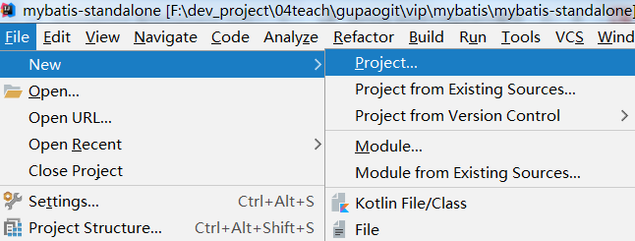

1. Spring Initializr 工程

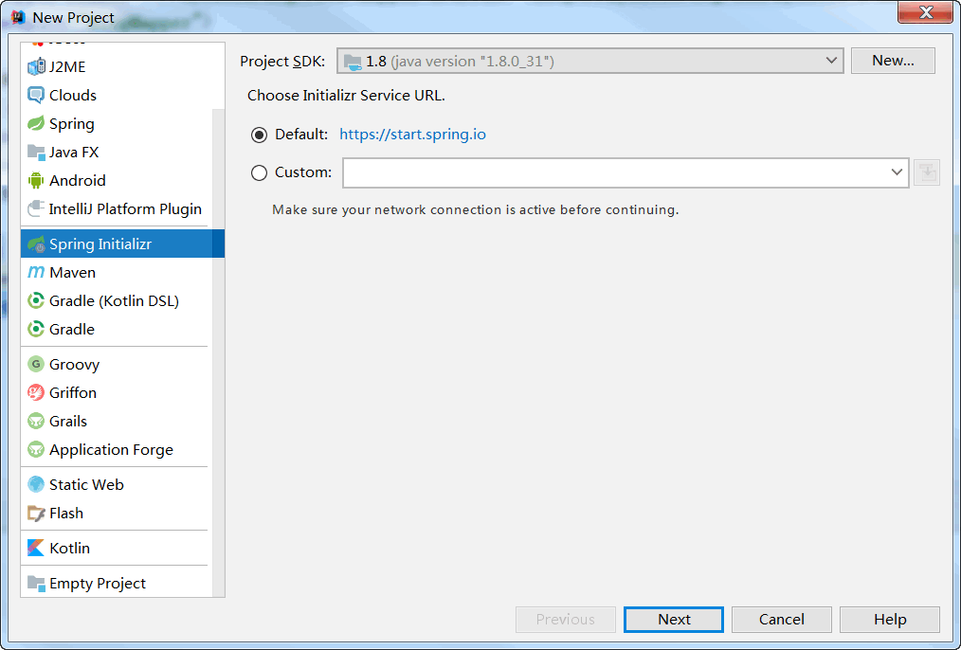

1. 填写相关信息

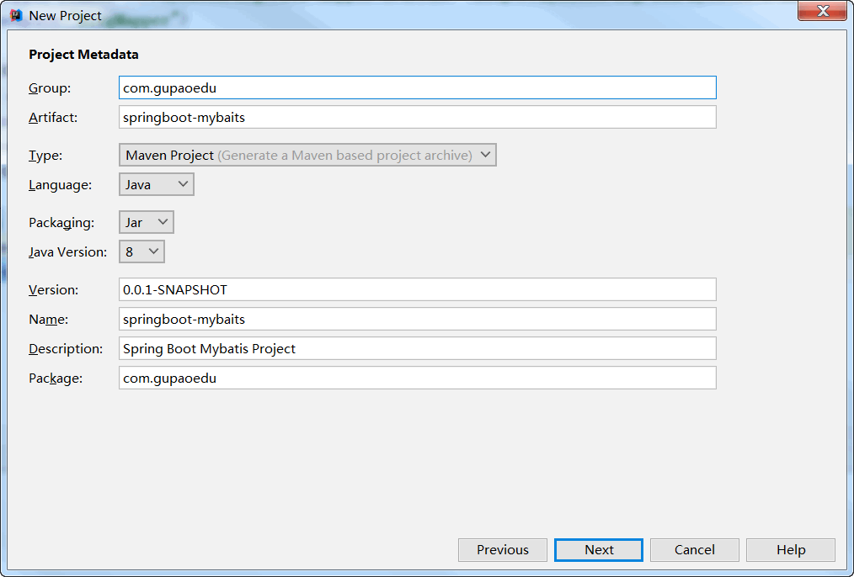

1. 选择依赖

Web勾选Web

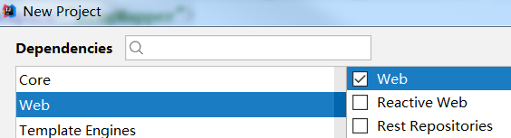

SQL勾选JPA、MySQL、MyBatis

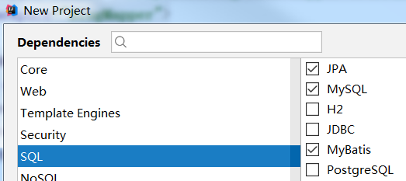

1. 项目名称与路径

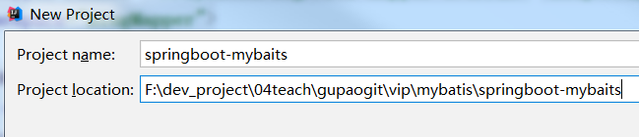

1. entity包下创建实体类

|  |
| --- |
| **public class** Blog {  Integer **bid**; *// 文章ID* String **name**; *// 文章标题* String **authorId**; *// 文章作者ID* **public** Integer getBid() {  **return bid**;  }   **public void** setBid(Integer bid) {  **this**.**bid** = bid;  }   **public** String getName() {  **return name**;  }   **public void** setName(String name) {  **this**.**name** = name;  }   **public** String getAuthorId() {  **return authorId**;  }   **public void** setAuthorId(String authorId) {  **this**.**authorId** = authorId;  }   @Override  **public** String toString() {  **return "Blog{"** +  **"bid="** + **bid** +  **", name='"** + **name** + **'\''** +  **", authorId='"** + **authorId** + **'\''** +  **'}'**;  } } |

1. controller包下创建Controller类

|  |
| --- |
| @RestController @EnableAutoConfiguration @RequestMapping(**"/blog"**) **public class** BlogController {  @RequestMapping(**"list"**)  **public** Blog getBlog() {  Blog blog = **new** Blog();  blog.setName(**"如何进入BAT"**);  **return** blog;  } } |

1. 配置数据源

application.yml

|  |
| --- |
| *#默认使用配置* **spring:  profiles:  active:** dev  *#公共配置与profiles选择无关* **mybatis:  typeAliasesPackage:** com.gupaoedu.entity  **mapperLocations:** classpath:mapper/*.xml  ---  *#开发配置* **spring:  profiles:** dev   **datasource:  url:** jdbc:mysql://localhost:3306/gp-mybatis?characterEncoding=utf8&useSSL=false&serverTimezone=UTC&rewriteBatchedStatements=true  **username:** root  **password:** 123456  **driver-class-name:** com.mysql.cj.jdbc.Driver |

8、创建接口Service和实现类Impl

**package** com.gupaoedu.service;

|  |
| --- |
| **public interface** BlogService {  **public** Blog getBlogById(**int** bid);   **int** addBlog(Blog blog); } |

**package** com.gupaoedu.service.impl;

|  |
| --- |
| @Component **public class** BlogServiceImpl **implements** BlogService {  @Autowired  BlogMapper **blogMapper**;   @Override  **public** Blog getBlogById(**int** bid) {  **return blogMapper**.selectByPrimaryKey(bid);  }   @Override  **public int** addBlog(Blog blog) {  **return blogMapper**.insert(blog);  } } |

Service注入到Controller中

|  |
| --- |
| @RequestMapping(**"/dblist"**) @ResponseBody **public** Blog toIndex(HttpServletRequest request ){  **int** bid = Integer.*parseInt*(request.getParameter(**"bid"**));  Blog blog = **this**.**blogService**.getBlogById(bid);  **return** blog; } |

9、修改Application启动类

@MapperScan(**"com.gupaoedu.dao"**)

10、如果Mapper.xml扫描不到，在pom文件中加入

<**resource**>  
 <**directory**>src/main/java</**directory**>  
 <**includes**>  
 <**include**>**/mapper/*Mapper.xml</**include**>  
 </**includes**>  
</**resource**>

11、启动应用

访问：*http://localhost:8080/blog/dblist?bid=1*